🧭 PHASE 0 — Project Setup (Day 1)
✅ 1. Define your system
Project name:
Smart Service Booking System
Decide:
- What can be booked? (pick ONE to keep it simple)
  - Study rooms ✅ (recommended)
  - Tutors
  - Events
👉 Keep it focused → easier to build + test

✅ 2. Decide roles
- User (student/customer)
- Admin

✅ 3. Set up tools
Install:
- Node.js
- MySQL
- VS Code
- Git
Create project:
/frontend (React)
/backend (Node.js)
/database (SQL files)

🧠 PHASE 1 — UX DESIGN (Assignment 2 - LO1)
✅ 4. Create Personas (2 minimum)
Example:
Persona 1:
- Name: Student Sam
- Goal: Book a study room quickly
- Pain point: Complicated systems
Persona 2:
- Name: Admin Alex
- Goal: Manage rooms efficiently

✅ 5. Write User Stories (at least 4–6)
Example:
- As a user, I want to log in so that I can access booking features
- As a user, I want to book a room so that I can study
- As an admin, I want to add rooms so that users can book them

✅ 6. Draw Wireframes
Use:
- Figma / paper
Draw:
- Login page
- Dashboard (room list)
- Booking page
- Admin panel

✅ 7. Plan UI Flow
Flow:
Login → Dashboard → Select Room → Choose Time → Confirm Booking

🏗️ PHASE 2 — ASSIGNMENT 1 TASK 1 (DESIGN DOCUMENT)
✅ 8. Functional Requirements (write 8)
Use format:
The system shall...
(You already have examples from earlier)

✅ 9. Non-functional Requirements (3)
Define measurable targets:
- Performance → response ≤ 500ms
- Maintainability → low complexity
- Security → role-based access

✅ 10. Architecture
Compare:
- Layered Architecture
- MVC
👉 Choose Layered Architecture

✅ 11. Draw Diagrams
You MUST create:
📦 Component Diagram
- Frontend
- Backend
- Database

🧱 Class Diagram (6+ classes)
Include:
- User
- Admin
- Booking
- Room
- AuthService
- BookingService

🔁 Sequence Diagram
Example:
- User books a room

✅ 12. Design Patterns
Choose:
Pattern 1: Singleton
- DB connection
Pattern 2: Factory
- Create booking/service

✅ 13. Quality Attribute Plan
Define:
- What you measure
- How (tools)

💻 PHASE 3 — DEVELOPMENT (Assignment 1 Task 2 + Assignment 2)
✅ 14. Backend (Node.js)
Create:
Core features:
- Login API
- Register API
- Get rooms
- Book room
- Cancel booking
- Admin: add room

✅ 15. Database (MySQL)
Create tables:
- Users
- Rooms
- Bookings

✅ 16. Frontend (React)
Build pages:
Pages:
- Login/Register
- Dashboard
- Booking page
- Admin page

✅ 17. Event-driven UI (VERY IMPORTANT)
Implement:
- Button clicks
- Form validation
- Error messages
- Success messages
Example:
- Click “Book” → triggers API
- Show feedback instantly

✅ 18. Use Tailwind for UI
Make sure:
- Clean layout
- Responsive design (mobile + desktop)

🧪 PHASE 4 — TESTING (Assignment 1 Task 3)
✅ 19. Unit Tests (10)
Test:
- Login
- Booking logic
- Prevent double booking

✅ 20. Integration Tests (3)
Test:
- Login → booking flow
- Admin → add room

✅ 21. Security Tests
Try:
- Wrong password
- Access admin as user
- Invalid input

📊 PHASE 5 — METRICS (Assignment 1 Task 4)
✅ 22. Use a tool
Pick one:
- SonarQube
- VS Code Metrics

✅ 23. Collect metrics
At least 3:
- Cyclomatic complexity
- Maintainability index
- Lines of code

✅ 24. Analyse
Write:
- What each metric means
- Problems found
- Improvements

🧾 PHASE 6 — DOCUMENTATION
✅ 25. Final Report Structure
Task 1:
- Requirements
- Architecture
- Patterns
- Diagrams
Task 2:
- Development process
- Screenshots
Task 3:
- Tests + results
Task 4:
- Metrics analysis

✅ 26. README
Include:
- How to run backend
- How to run frontend
- Database setup

🎤 PHASE 7 — PRESENTATION
✅ 27. Demo
Show:
- Login
- Booking
- Admin feature

✅ 28. Explain
Be ready to talk about:
- Architecture
- Design patterns
- UX decisions

📁 FULL PROJECT STRUCTURE
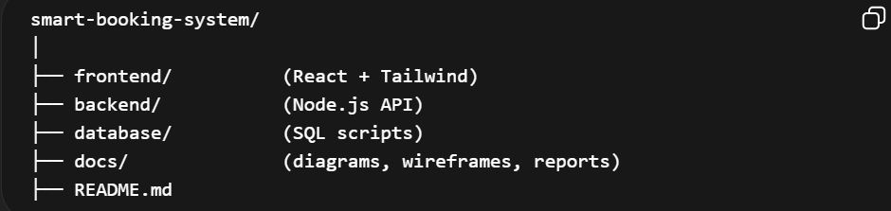
🎨 FRONTEND (React + Tailwind)
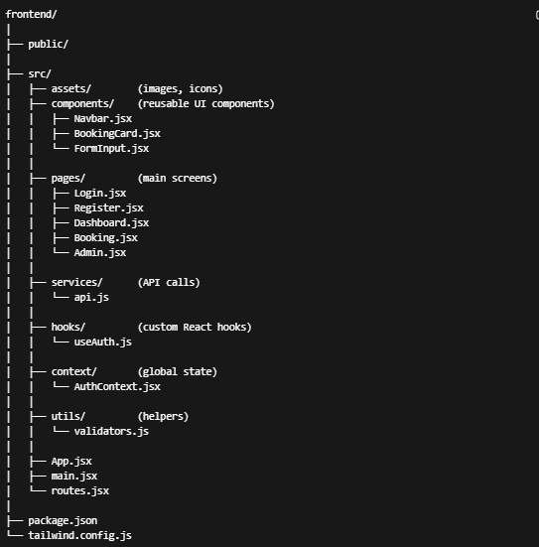

✅ Why this is good (for marking)
- Separation of concerns → maintainability ✔
- Reusable components → good design ✔
- API isolated → clean architecture ✔

⚙️ BACKEND (Node.js — Layered Architecture)
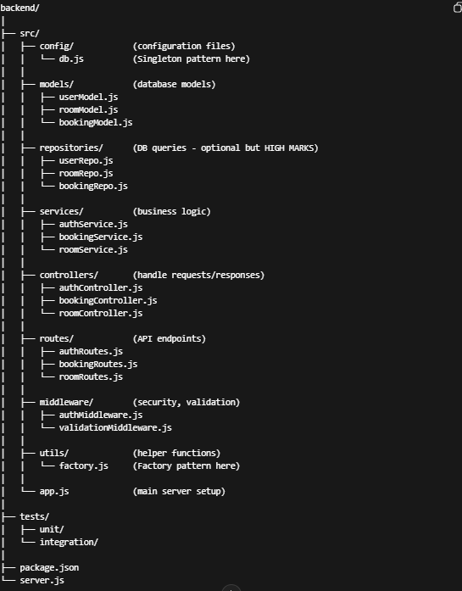

🧠 Why this structure is PERFECT for Assignment 1
🔹 Shows Layered Architecture clearly:
- Routes → Controllers → Services → Repositories → DB
👉 You can literally point to this in your report = easy marks

🧩 Where your design patterns go
✅ Singleton
config/db.js
- One database connection

✅ Factory
utils/factory.js
- Creates booking/service types

🗄️ DATABASE FOLDER
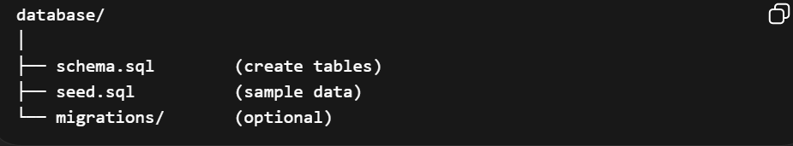

📄 DOCS FOLDER (VERY IMPORTANT FOR MARKS)
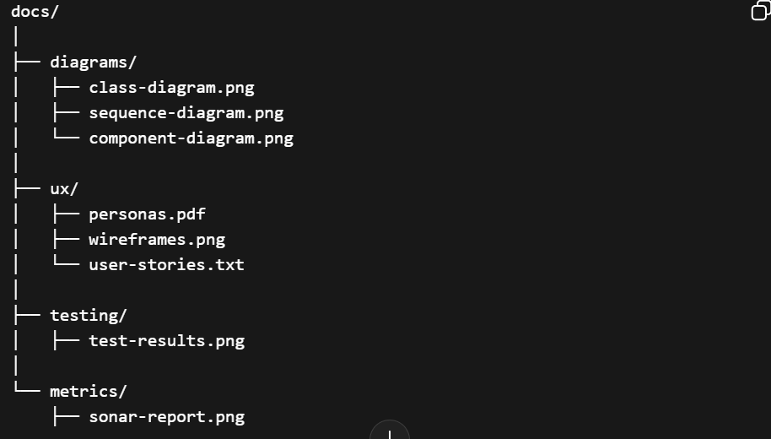

🧪 TESTING STRUCTURE
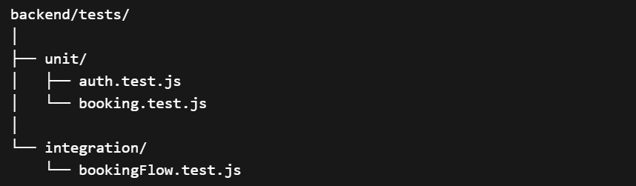

🚀 BONUS (for higher marks)
Add:
backend/src/interfaces/
👉 Shows abstraction → improves maintainability marks

⚠️ Common mistakes to AVOID
❌ Putting all logic in one file
❌ Mixing frontend + backend code
❌ Business logic inside controllers
❌ No separation of concerns

💥 Final takeaway
👉 This structure:
- Clearly demonstrates Layered Architecture
- Makes design patterns easy to show
- Improves maintainability metrics
- Helps you get higher marks in EVERY task

